**LAPORAN PRAKTIKUM**

**CSS PADA WEB**

**PEMROGRAMAN WEB**



**Disusun oleh :**

Muhammad Guntur R A

201601044

**Dosen Pengampu :**

Oskar Ika Adi Nugroho., S.T.,M.T.

**JURUSAN SISTEM INFORMASI**

**SEKOLAH TINGGI ILMU KOMPUTER “YOS SUDARSO”**

**PURWOKERTO**

**2019**

1. Source Code HTML
2. <!DOCTYPE html>
3. <html>
4. <head>
5. <title> Tugas web </title>
6. <link rel ="stylesheet" type="text/css" href="nomor1.css">
7. </head>
8. <body>
9. <div class="box">
10. <div class="kotak1 kotak1">
11. <div class="kotak2 kotak2">
12. <font size="5px"> Hello Yeye.
14. </font>
15. </div>
16. </div>
17. </div>
18. </body>
19. </html>

Source Code CSS

body{

background: blue;

text-align: center;

}

.box{

width: 1150px;

}

.kotak1{

width: 300px;

height: 185px;

padding: 15px;

background:rgb(0, 0, 0);

}

.kotak2{

width: auto;

height: 185px;

margin:5px 5px 5px 5px;

background: rgb(118, 159, 170);

border-radius: 20px 20px 20px 20px;

}

Output

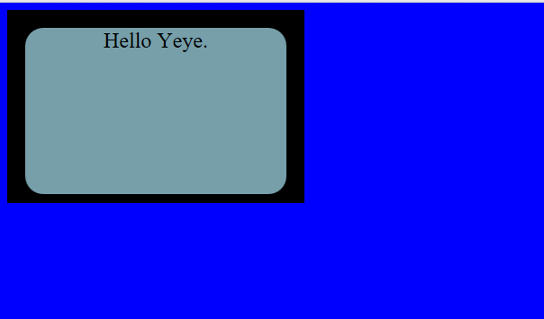

2.Source Code HTML

<!DOCTYPE html>

<html lang="en">

<head>

<title>Tugas web</title>

<link rel="stylesheet" type="text/css" href="nomer2.css">

</head>

<body>

<div class="octagon">

<div class="teksnya">

Purwokerto

</div>

</div>

</body>

</html>

Source Code CSS

.octagon {

width: 200px;

height: 155px;

background: rgba(205, 180, 207, 0.603);

position: relative;

margin:0 auto;

}

.octagon .teksnya{

color: rgb(238, 95, 29);

padding-top : 15%;

margin: 10%;

text-align: justify;

}

.octagon:before {

content: "";

position: absolute;

top: 0;

left: 0;

border-bottom: 20px solid rgb(9, 69, 77);

border-left: 20px solid azure;

border-right: 20px solid azure;

width: 80%;

height: 0;

}

.octagon :after {

content: "";

position : absolute;

bottom : 0;

left: 0;

border-top: 20px solid rgb(181, 150, 214);

border-left: 20px solid azure;

border-right: 20px solid azure;

width: 80%;

height : 0;

}

Output

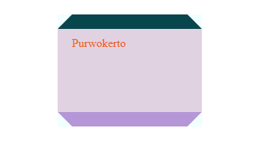

3.Source Code HTML

<!DOCTYPE html>

<html>

<head>

<title> Tugas 3</title>

</head>

<style>

.container {

width: 300px;

height: 200px;

margin: 0 auto;

background-image: repeating-linear-gradient(135deg, yellow 0px,rgb(0, 255, 128) 15px, pink 15px, rgb(0, 183, 255) 25px,

rgb(0, 4, 255) 25px, rgb(255, 0, 200) 40px, white 40px, white 50px);

padding: 12px;

}

.container .inner {

background: white;

width: 300px;

height: 200px;

}

</style>

<body>

<div class="container">

<div class="inner">

dikirim oleh Guntur

</div>

</div>

</body>

</html>

Output

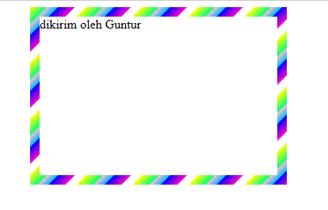

4.Source Code HTML

<!DOCTYPE html>

<html>

<head>

<meta name="viewport" content="width=device-width, initial-scale=2">

<style>

.parallelogram {

float: left; align: center; padding:10px; margin:5px;

width: 170px; height: 40px; transform: skew(25deg);

background: #4ed433;

}

.parallelogram2 {

float: left; align: center; padding:10px; margin:5px;

width: 190px; height: 40px; transform: skew(25deg);

background: #9baac9;

}

.tulisan {

font : 20px Arial red; align: center; margin:5px;

color : red; width: 150px; height: 15px;

transform: skew(-25deg);

}

.tulisan2 {

font : 20px Arial red; align: center; margin:5px;

color : red; width: 170px; height: 15px;

transform: skew(-25deg);

}

</style>

</head>

<body>

<div class="parallelogram" >

<div class="tulisan"> <B >yos sudarso</B>

</div>

</div>

<div class="parallelogram2">

<div class="tulisan"> <B>purwokerto</B>

</div>

</div>

</body>

</html>

Output

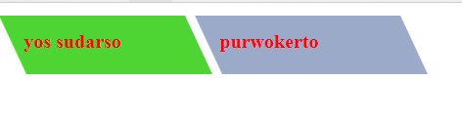

5.Source Code HTML

<html lang="en">

<head>

<title>kode5</title>

<link rel="stylesheet" type="text/css" href="nomer5.css">

</head>

<body>

<div class="diagram">

<div class="dig" style="background-color: inherit;transform: rotate(.2turn);"></div>

</div>

<div class="diagram">

<div class="dig" style="background-color: rgb(115, 236, 236);transform:rotate(.1turn);"></div>

</div>

</body>

</html>

Source Code CSS

.diagram{

float: left;

margin: 5px;

width: 100px;

height: 100px;

border-radius: 50%;

background-image: linear-gradient(to right, transparent 50%, rgb(150, 13, 168) 0);

}

.diagram .dig {

content: '';

display: block;

margin-left: 50%;

height: 100%;

border-radius: 0 100% 100% 0 / 50%;

transform-origin: left

}

Output

